H3 - Sampling-bout locations vs odor-reached regions
Selective Sampling-Bout analysis (reactions_2). Trial-level inference; pooled Loc1-6.

Headline
H3 is NOT supported. Sampling-bout onset locations are NOT enriched in odor-reached bins. The median in-odor fraction of bout onsets (f_bout = 0.000) is BELOW the occupancy expectation (f_occ = 0.308): bouts occur where the animal spends relatively LESS of its time in odor-reached regions, i.e. the effect runs in the negative direction. The trial-level Wilcoxon test of enrichment (f_bout > f_occ) gives p = 0.994 (one-sided, n = 67 contributing trials), and only 25.4% of trials are enriched (below the ~50% chance level). Direction is reported before significance; this is a clean, honest null.

Goal and hypotheses
Goal. Test whether the head positions at sampling-bout onset are spatially biased toward regions the odor plume plausibly reached, beyond what the animal's occupancy alone predicts.
H3. Sampling-bout locations (head at bout onset) are enriched in odor-reached bins relative to where the animal spends its time (f_bout > f_occ, and f_bout above a within-trial permutation null).
H0. The in-odor fraction of bout onsets equals the occupancy-based expectation (f_bout = f_occ; f_bout - null = 0).
Decision rule. Accept H3 iff bouts are significantly enriched beyond occupancy. Outcome: accept_H3 = False.

Methods
Accessors and common code. All quantities were computed upstream by build_bouts.py using reactions2_common (reactions2_common/1.0), which reuses the validated plume_common / reactions_common accessors (advancing-reference de-jump track cleaning, baseline-subtracted ethanol on the head clock, the Plume-locations odor-field lookup). This report and the figure recompute no science; every number is injected from saved result objects (data\stats.json, data\bouts.h5).
Interpreter and seed. Python at the vras environment; matplotlib headless (Agg); random seed 1234 throughout.
Odor-reached region (D9). Reused from the Plume-locations odor fields (Plume locations\data\odor_fields.h5). For a trial's release location, a spatial bin is 'odor-reached' iff it is valid (count >= 3 trials) AND its max ethanol field exceeds the cutoff 0.001 (above the ~4e-4 noise floor). A bout onset is 'in-odor' if the head position at onset maps to an odor-reached bin.
Per-trial statistics. For each trial: f_bout = fraction of bout onsets falling in odor-reached bins; f_occ = fraction of all kept head frames in odor-reached bins (the occupancy expectation). A within-trial permutation null draws n_bout random frame times and computes their in-odor fraction (2000 draws), yielding a per-trial (f_bout - mean(null)).
Inference. Replication unit = trial. One statistic per trial; enrichment tested by trial-level one-sided Wilcoxon signed-rank tests (f_bout > f_occ and f_bout - null > 0) across trials with >= 1 bout; trial bootstrap 2000 draws where CIs are used. Pooled Loc1-6 (n = 105 trials); anotherLoc (n = 9) kept separate. Only trials with >= 1 bout contribute to bout-conditioned tests (n = 67).

Results
Direction (reported first).
Across contributing trials the median in-odor fraction of bout onsets is f_bout = 0.000, versus a median occupancy fraction f_occ = 0.308. The median within-trial (f_bout - null) is -0.2015. All three point the same way: bout onsets are UNDER-represented in odor-reached bins relative to occupancy and to the permutation null.
Significance (enrichment tests).
f_bout > f_occ: Wilcoxon signed-rank stat = 740, one-sided p = 0.994 (n = 67 trials).
f_bout > within-trial null: Wilcoxon signed-rank stat = 746, one-sided p = 0.993 (n = 67 trials).
Fraction of trials enriched (f_bout > f_occ): 25.4% -- below the ~50% chance level, consistent with no enrichment (and, if anything, a mild anti-enrichment).
Amplitude check. The odor field at the mapped bins is above the noise floor (amplitude_above_floor = True; cutoff 0.001 vs ~4e-4 floor), so the null is not an artifact of a dead / sub-threshold odor field.
Interpretation.
Both the direction and the (non-)significance agree: sampling-bout onset locations are not enriched where odor plausibly reached. Bouts are, if anything, slightly under-represented in odor-reached bins relative to how the animal distributes its time. H3 is not supported.

Figure F3
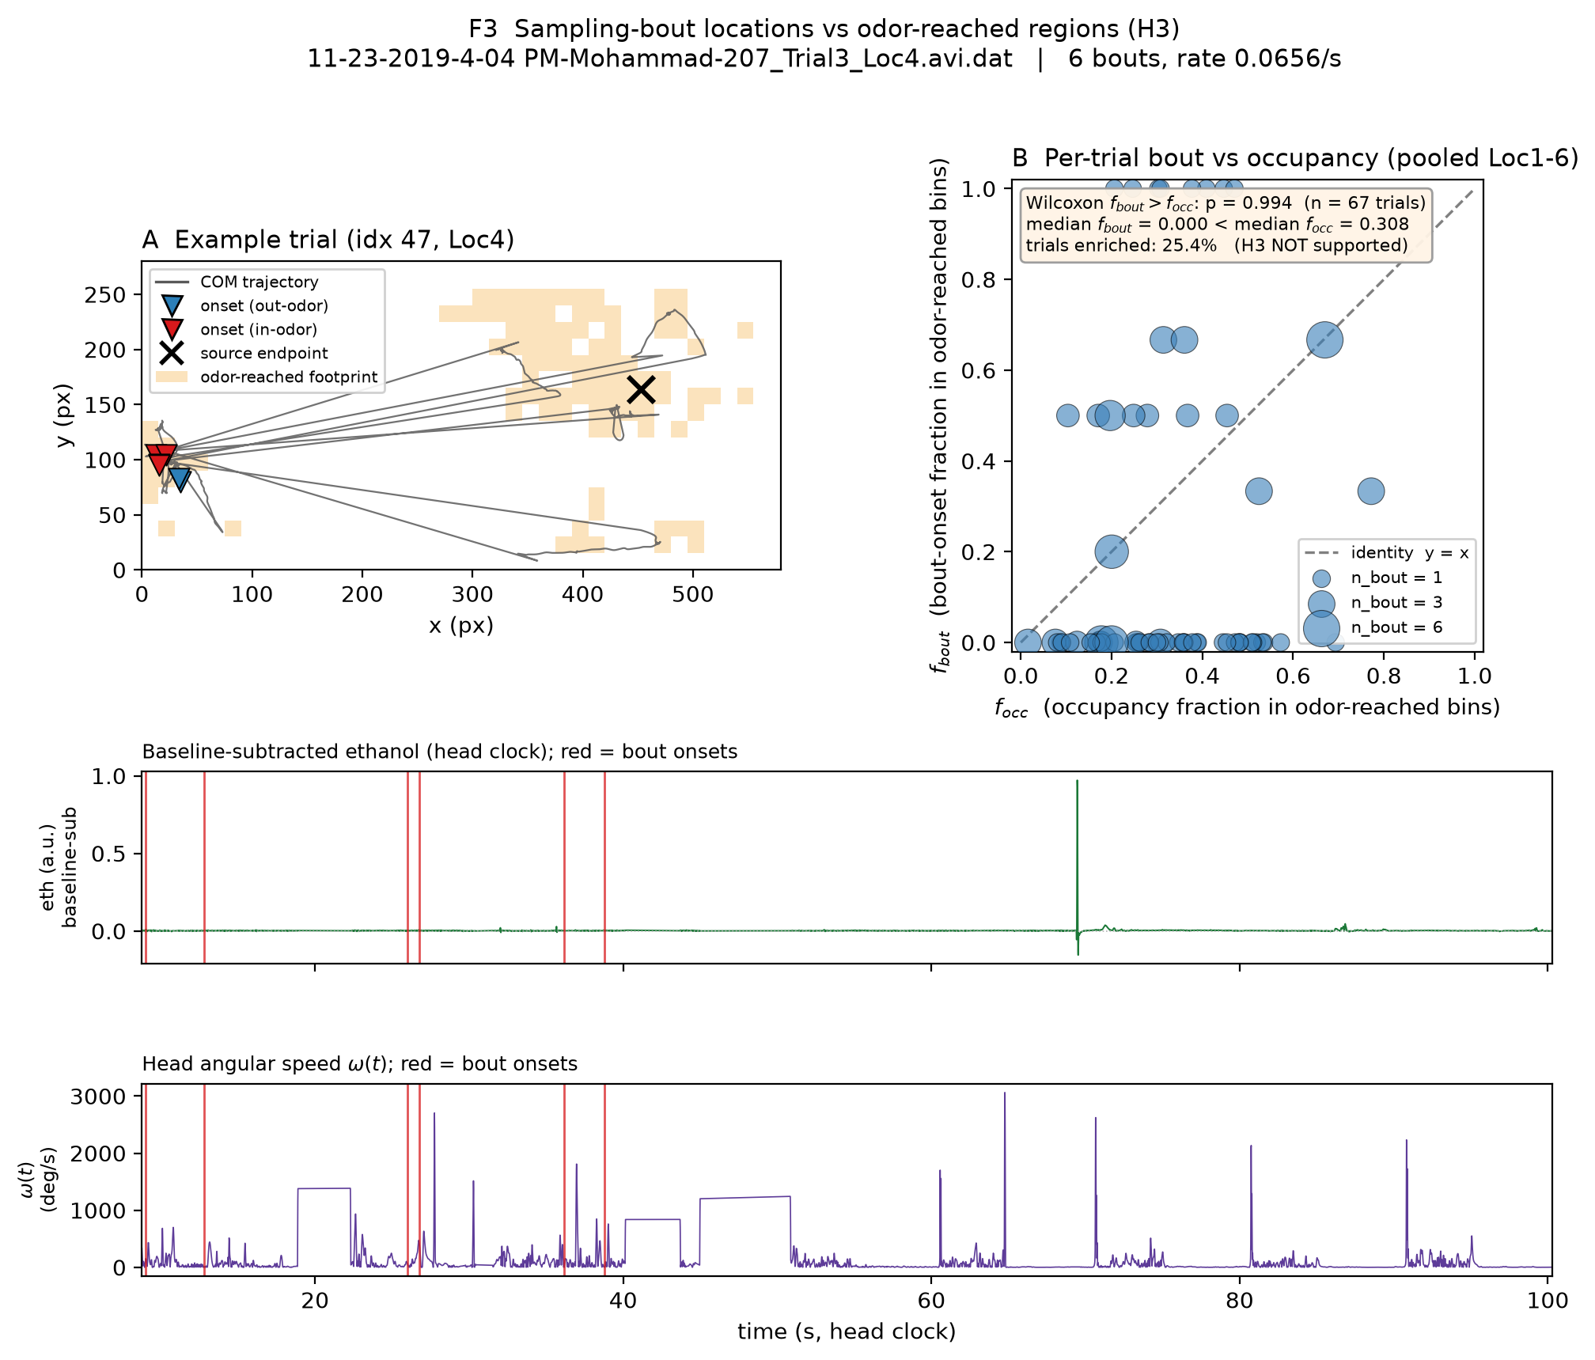
Figure F3. Sampling-bout locations vs odor-reached regions (H3). (A) Example trial (index 47, Loc4; 11-23-2019-4-04 PM-Mohammad-207_Trial3_Loc4.avi.dat; 6 bouts, rate 0.0656/s): cleaned centre-of-mass trajectory in the arena box ([0,580] x [0,280] px, equal aspect); the odor-reached footprint for that location (bins with count >= 3 and max > 0.001) is lightly shaded; bout-onset head positions are marked (triangles; red = in-odor, blue = out-of-odor) and the source endpoint is marked with an x. Below: the trial's baseline-subtracted ethanol (a.u.) and head angular speed omega(t) (deg/s) on the head clock, with bout onsets marked in red in both. (B) Per-trial f_bout (y) vs f_occ (x) for all pooled Loc1-6 trials with >= 1 bout (n = 67); the dashed line is the identity y = x; point size is proportional to n_bout. Most points fall below the identity line. Trial-level Wilcoxon f_bout > f_occ p = 0.994; 25.4% of trials enriched. H3 not supported.

Caveats
Reused odor field. The odor-reached mask is derived from the Plume-locations odor fields aggregated across a separate set of trials per location, not measured concurrently with each reaction trial; it is a plausibility footprint, not an instantaneous odor map.
Modest N. Only 67 trials carry at least one sampling bout, limiting power for the enrichment tests; the many single-bout trials make per-trial f_bout coarse (0 or 1 for n_bout = 1).
Single cohort / pixel resolution. Results come from one cohort at fixed spatial binning (15-px bins); the footprint definition and bin size could shift borderline in/out-of-odor assignments. The direction and magnitude of the null, however, are not marginal.

Reproducibility
Generated 2026-08-09 00:34 UTC. seed 1234; reactions2_common/1.0. All numbers injected from saved objects; no science recomputed.
Inputs: data\stats.json (H3 block), data\bouts.h5 (/trials/047 arrays and /trials/<idx> attrs), Plume locations\data\odor_fields.h5 (odor-reached footprint).
Rebuild: run code\make_F3.py then code\make_H3_report.py with the vras interpreter ("$AR_PY"); e.g. "$AR_PY" -m compileall code\make_H3_report.py ; "$AR_PY" code\make_H3_report.py .

